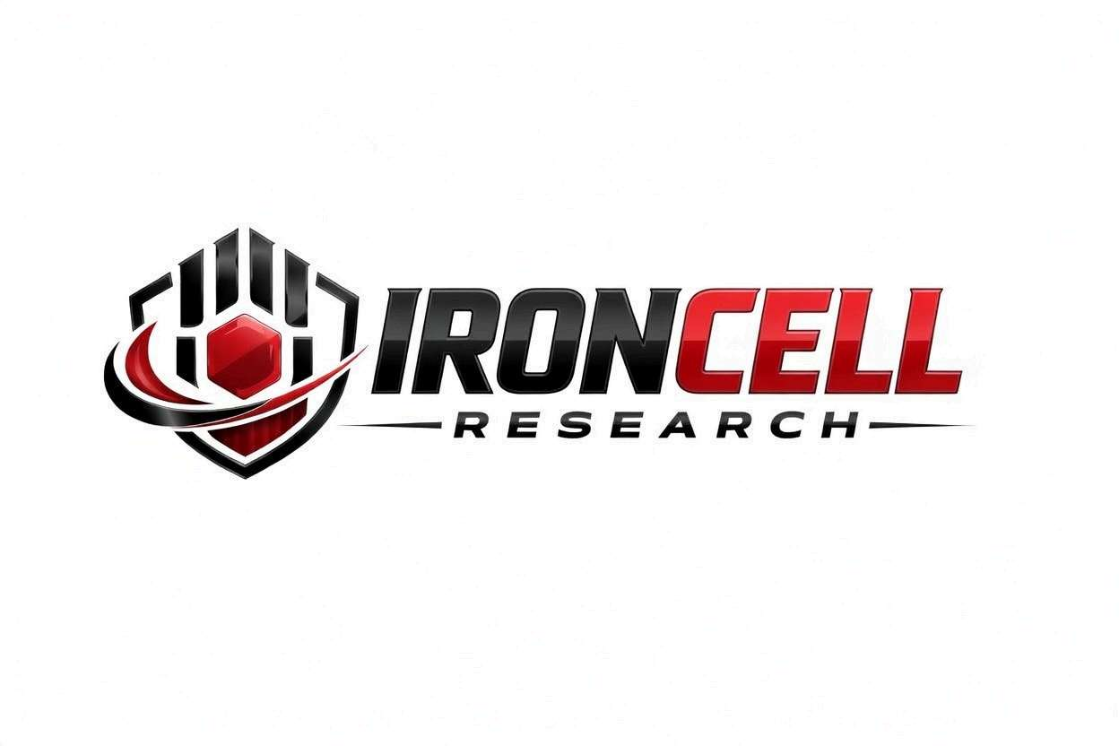
PEPTIDE RESEARCH BRIEF
NAD+
Nicotinamide Adenine Dinucleotide | Cellular Energy & Longevity Coenzyme

Description, Benefits, Dosage & Research Overview

Iron Cell Research
IronCellResearch.com
For Research Use Only


Compound Overview
Compound Name | NAD+ (Nicotinamide Adenine Dinucleotide)
Classification | Coenzyme / Dinucleotide
Molecular Formula | C21H27N7O14P2
Molecular Weight | 663.43 g/mol
CAS Number | 53-84-9
Biological Half-Life | 1-4 hours (tissue dependent)
Purity | Greater than or equal to 99%
Storage | Lyophilized, -20C to 4C, protected from light
Research Status | Extensive preclinical & clinical research

Description
NAD+ is a critical coenzyme found in every living cell. It plays a central role in cellular energy metabolism, serving as an essential electron carrier in the mitochondrial electron transport chain and as a key substrate for enzymes involved in DNA repair, gene expression, and cellular signaling.
NAD+ levels naturally decline with age, and this decline has been linked to metabolic dysfunction, neurodegeneration, cardiovascular disease, and impaired immune function. Direct NAD+ supplementation provides the fully formed coenzyme, bypassing the need for biosynthetic conversion steps required by precursors such as NMN or NR.

Mechanism of Action

Mitochondrial Energy Production
NAD+ functions as a primary electron carrier in the mitochondrial electron transport chain. It accepts electrons during the citric acid cycle (as NADH) and donates them to Complex I of the respiratory chain, driving oxidative phosphorylation and ATP synthesis.

Sirtuin Activation
NAD+ is the obligate co-substrate for sirtuins (SIRT1-SIRT7), a family of NAD+-dependent deacylases. Sirtuins regulate gene silencing, DNA repair, mitochondrial biogenesis, inflammation, and stress resistance. Higher NAD+ levels enhance sirtuin activity, promoting cellular resilience and longevity pathways.

DNA Repair & Genome Integrity
NAD+ is consumed by poly(ADP-ribose) polymerases (PARPs), particularly PARP1 and PARP2, which are critical in the DNA damage response. PARPs use NAD+ to synthesize poly(ADP-ribose) chains that recruit repair machinery to damaged sites.

Immune & Inflammatory Regulation
NAD+ is a substrate for CD38, an ectoenzyme on immune cells that generates the calcium-mobilizing messenger cyclic ADP-ribose. CD38 activity increases with age and chronic inflammation, contributing significantly to age-related NAD+ decline. NAD+ repletion modulates inflammatory responses and supports immune cell function.

Research Benefits

Anti-Aging & Longevity
- Cellular Rejuvenation: NAD+ repletion reverses age-related decline in mitochondrial function and restores youthful metabolic profiles.
- Sirtuin-Mediated Longevity: SIRT1 and SIRT3 activation promotes mitochondrial biogenesis, autophagy, and stress resistance.
- Telomere Protection: Research indicates NAD+ supports telomere maintenance through sirtuin-dependent mechanisms.

Neuroprotection
- Neuronal Energy: Critical for neuronal ATP production and axonal energy supply.
- Neurodegenerative Models: Protective effects in preclinical Alzheimer's, Parkinson's, and ALS models.
- Blood-Brain Barrier: Supports BBB function and cerebrovascular health.

Metabolic Health
- Insulin Sensitivity: Improves glucose tolerance and insulin sensitivity in metabolic syndrome models.
- Lipid Metabolism: Promotes fatty acid oxidation and reduces hepatic lipid accumulation.
- Weight Management: Enhanced mitochondrial function supports improved metabolic rate.

Cardiovascular
- Cardiac Protection: Cardioprotective effects in heart failure and ischemia-reperfusion models.
- Vascular Health: Supports endothelial function and vascular elasticity through SIRT1 pathways.
- Arterial Stiffness: May reverse age-related arterial stiffness.

Exercise Performance
- Muscle Endurance: Supports mitochondrial biogenesis in skeletal muscle.
- Recovery: Promotes efficient energy production and reduces oxidative stress.
- Muscle Stem Cells: Rejuvenates muscle stem cells in aged animals.

Dosage & Administration
The following dosage information is provided for research reference purposes only.
Protocol | Dose Range | Route | Frequency
Low / Maintenance | 100-250 mg | IV Infusion | 1-2x per week
Standard | 250-500 mg | IV Infusion | 1-2x per week
High / Loading | 500-1000 mg | IV Infusion | Daily x 3-5 days
Subcutaneous | 50-200 mg | SubQ Injection | Daily or as directed

Reconstitution Guidelines
Solvent | Sterile bacteriostatic water or sterile saline
Mixing | Gently swirl, do not shake
Storage After Reconstitution | Refrigerate at 2-8C, use within 14 days
IV Infusion Rate | Slow drip over 1-4 hours (dose dependent)
SubQ Injection | Rotate injection sites, room temperature
Note: IV infusion of NAD+ is typically administered slowly to minimize side effects such as nausea, chest tightness, and cramping.

Safety Profile
NAD+ has been administered in clinical and research settings with a generally favorable safety profile:
- Infusion-Related Effects: Nausea, chest pressure, cramping, and flushing may occur with IV infusion, particularly with faster rates. These are transient and resolve when the rate is reduced.
- SubQ Reactions: Mild redness or discomfort at injection sites may occur.
- Drug Interactions: May interact with PARP inhibitors and certain chemotherapeutic agents.
- Contraindications: Caution with active malignancies. Hypersensitivity to NAD+ or its components.
- Pregnancy & Nursing: Insufficient safety data; use not recommended.

Key References
- Yoshino J, Baur JA, Imai SI. NAD+ Intermediates: The Biology and Therapeutic Potential of NMN and NR. Cell Metabolism. 2018;27(3):513-528.
- Verdin E. NAD+ in Aging, Metabolism, and Neurodegeneration. Science. 2015;350(6265):1208-1213.
- Rajman L, Chwalek K, Sinclair DA. Therapeutic Potential of NAD-Boosting Molecules. Cell Metabolism. 2018;27(3):529-547.
- Imai SI, Guarente L. NAD+ and Sirtuins in Aging and Disease. Trends in Cell Biology. 2014;24(8):464-471.
- Camacho-Pereira J, et al. CD38 Dictates Age-Related NAD Decline. Cell Metabolism. 2016;23(6):1127-1139.
- Zhang H, et al. NAD+ Repletion Improves Mitochondrial and Stem Cell Function. Science. 2016;352(6292):1436-1443.
- Braidy N, et al. Role of NAD+ and Related Precursors as Therapeutic Targets. Antioxidants & Redox Signaling. 2019;30(2):251-294.
- Katsyuba E, et al. NAD+ Homeostasis in Health and Disease. Nature Metabolism. 2020;2(1):9-31.

Contact & Information
Company | Iron Cell Research
Website | IronCellResearch.com
Email | orders@ironcellresearch.com
Product Support | Available via website contact form

Disclaimer
This document is intended for informational and research purposes only. NAD+ is sold as a research compound and is not intended for human consumption. The information provided herein does not constitute medical advice, diagnosis, or treatment recommendations. All research applications should comply with applicable institutional, local, and federal regulations. Iron Cell Research makes no claims regarding the therapeutic efficacy of NAD+ for any medical condition. Researchers should consult with qualified healthcare professionals and institutional review boards before initiating any research protocols involving human subjects.
Iron Cell Research - For Research Use Only


